RECURSION QUESTIONS

Table of Contents
LEVEL 1: Easy 2
1. Assign Cookies 2
2. Boats to Save People 2
3. Jump Game 2
4. Fractional Knapsack 2
5. Non-Overlapping Intervals 2
6. Two City Scheduling 2
LEVEL 2: Moderate 3
LEVEL 3: Difficult 4
Level 2 5
Level 3 6
SOLUTIONS 7
LEVEL 1: 7

LEVEL 1: Easy

Assign Cookies
https://leetcode.com/problems/assign-cookies/

Boats to Save People
https://leetcode.com/problems/boats-to-save-people/

Jump Game
https://leetcode.com/problems/jump-game/

Fractional Knapsack
https://www.geeksforgeeks.org/problems/fractional-knapsack-1587115620/1

Non-Overlapping Intervals
https://leetcode.com/problems/non-overlapping-intervals/

Two City Scheduling
https://leetcode.com/problems/two-city-scheduling/

LEVEL 2: Moderate

LEVEL 3: Difficult

Level 2 — Applied Greedy (intervals, strings, arrays with constraints)

Pattern 1 — Interval Scheduling
- Merge Intervals (56) LeetCode
- Insert Interval (57) LeetCode
- Remove Covered Intervals (1288) LeetCode
Pattern 2 — String Greedy
- Partition Labels (763) LeetCode
- Remove Duplicate Letters (316) LeetCode
- Remove K Digits (402) LeetCode
- Split a String in Balanced Strings (1221) LeetCode
Pattern 3 — Resource Allocation
- Gas Station (134) LeetCode
- Task Scheduler (621) LeetCode
- Minimum Cost to Move Chips (1217) LeetCode
- Put Boxes Into the Warehouse I (1564) LeetCode
Pattern 4 — Heap + Greedy
- Reorganize String (767) LeetCode
- Furthest Building You Can Reach (1642) LeetCode
- IPO (502) LeetCode
Pattern 5 — Scheduling
- Course Schedule III (630) LeetCode
- Two City Scheduling (1029) LeetCode
- Maximum Performance of a Team (1383) LeetCode
Pattern 7 — Classic GFG
- Job Sequencing Problem GeeksforGeeks
- Connect N Ropes with Minimum Cost GeeksforGeeks
- Huffman Coding GeeksforGeeks

Level 3 — Advanced / FAANG bar-raiser tier
- Minimum Number of Refueling Stops (LC 871) — greedy + heap
- Meeting Rooms II (LC 253) — heap-based interval greedy (Premium; GfG has an open equivalent)
- IPO / Maximize Capital (LC 502) — greedy + two heaps
- Split Array into Consecutive Subsequences (LC 659)
- Minimum Cost to Hire K Workers (LC 857) — ratio-sort + heap, hard bar-raiser question
- Advantage Shuffle (LC 870) — greedy matching
- Job Sequencing with Deadlines — GfG classic, frequently asked in service-based & product FAANG-adjacent interviews
- Chuck and Baseball / Minimum Platforms — GfG (interval overlap counting, common in Indian-market FAANG-prep sets)
Pattern 1 — Advanced Scheduling
- Course Schedule III (630) LeetCode
- Maximum Profit in Job Scheduling (1235) (Greedy intuition + DP) LeetCode
- Earliest Possible Day of Full Bloom (2136) LeetCode
Pattern 2 — Hard Interval Greedy
- Video Stitching (1024) LeetCode
- Minimum Taps to Water a Garden (1326) LeetCode
- Maximum Events That Can Be Attended (1353) LeetCode
Pattern 3 — Advanced String Greedy
- Create Maximum Number (321) LeetCode
- Smallest Subsequence of Distinct Characters (1081) LeetCode
- Rearrange String k Distance Apart LeetCode Premium
Pattern 4 — Optimization
- Candy (135) LeetCode
- Patching Array (330) LeetCode
- Broken Calculator (991) LeetCode
- Maximum Swap (670) LeetCode
- Minimize Cash Flow GeeksforGeeks

SOLUTIONS

LEVEL 1:

- Assign Cookies

class Solution:
def findContentChildren(self, g: List[int], s: List[int]) -> int:
i,j=0,0
g.sort()
s.sort()

while i<len(g) and j<len(s):
if g[i]<=s[j]:
i+=1
j+=1
else:
j+=1

return i

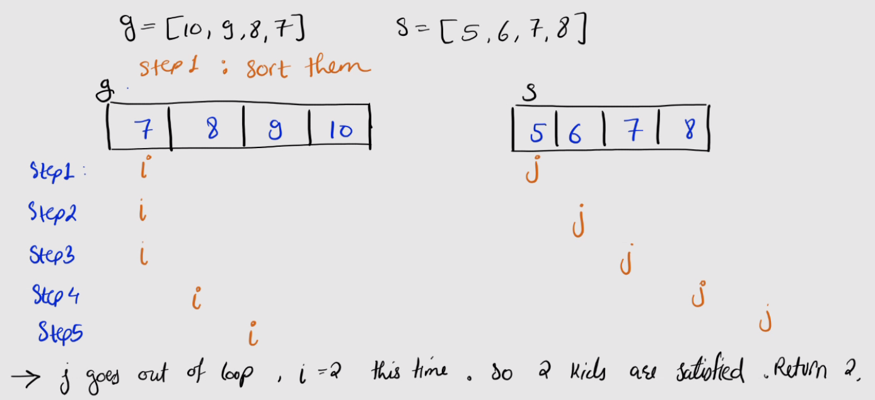

When to think greedy: The problem asks for an optimal count/min/max via local choices that don't need to be undone — often signaled by "maximum number of...", "minimum number of...", intervals/scheduling, or a hint that sorting exposes an obvious best-first order — and you can informally argue that the locally best choice never hurts future choices (exchange argument).
When not to: If a choice now can block a better global solution later — i.e. you need to consider trade-offs across choices (think subset sums, combinations affecting future state, or "count all ways" problems) — that's a sign you need DP/backtracking instead, since greedy can't undo an early bad pick.
- Boats to save people
Approach: Sort people. Use two pointers — one at the lightest, one at the heaviest. Try to pair the heaviest person with the lightest person in each boat; if their combined weight fits the limit, take both, otherwise the heaviest goes alone. Repeat until pointers cross.
Intuition: The heaviest remaining person must go on some boat, and pairing them with the lightest remaining person gives them the best possible chance of sharing a boat (since any other unpaired person is even heavier and less likely to fit). So greedily trying "heaviest + lightest" each round never wastes capacity — if even the lightest can't fit with the heaviest, no one can, and the heaviest must go alone.

class Solution:
def numRescueBoats(self, people: List[int], limit: int) -> int:
people.sort(reverse=True)
i, j = 0, len(people) - 1
boats = 0

while i <= j:
if people[i] + people[j] <= limit:
j -= 1 # lightest person paired, move down
i += 1 # heaviest person always leaves (alone or paired)
boats += 1

return boats

- Jump Game
Approach: Greedy, single pass — track the furthest index reachable so far (mj) as you scan left to right, without actually simulating individual jumps or paths.
Intuition: You don't care how you got to index i or which specific jump sequence you take — you only care about the maximum reach at any point. If your best possible reach ever falls behind your current position (mj < i), you're stuck, since even the most generous prior jump can't cross that gap. Conversely, if you can reach index i at all, then whatever jump options exist from i are worth folding into your "furthest reach" — because a bigger mj only ever helps future decisions, never hurts them. This is what makes greedy work here: keeping the single best global "reach" value is sufficient.
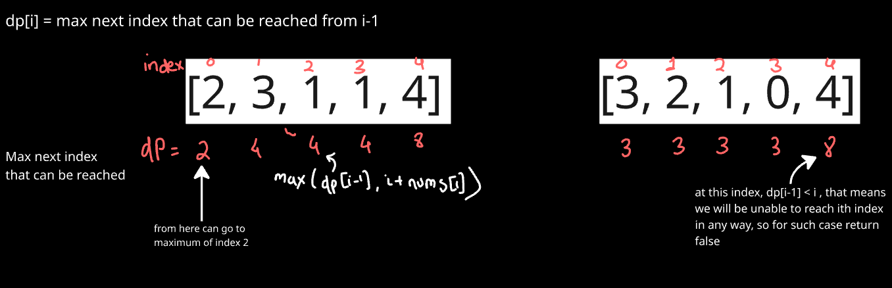

class Solution:
def canJump(self, nums: List[int]) -> bool:
mj=nums[0] #max jump

for i in range(1,len(nums)):
if mj<i:
return False
mj = max(mj, i+nums[i])

return True

- Fractional Knapsack
Intuition: Since you're allowed to take any fraction of an item, the "density" of value (value per unit weight) is all that matters — not the item's total value or total weight in isolation. An item with high v/w gives you the most value for every unit of capacity you spend on it, so it's always at least as good, and often strictly better, to fill your capacity with the densest items first.
Approach: Sort items by value-per-unit-weight (v/w), descending. Greedily fill the knapsack — take whole items as long as they fit, and if the next item doesn't fully fit, take just enough of it (a fraction) to fill the remaining capacity.

class Solution:
def fractionalKnapsack(self, val, wt, capacity):
#sort based on value per weight unit
n=len(val)
arr = [[val[i],wt[i]] for i in range(n)]
arr.sort(key = lambda x : -(x[0]/x[1]))

total=0
for item in arr:
v,w = item[0], item[1]
if w < capacity:
total += v
capacity-=w
else:
total += (v/w) * capacity #(value per unit weight)*left over capacity
return total

return total

- Non Overlapping Intervals
Intuition: This is the classic "activity selection" greedy problem. Sorting by end time is the key trick: an interval that ends earlier leaves more room for future intervals to fit in without overlapping, regardless of how long it started. So always preferring to keep the interval that frees up the earliest "end point" is never a bad choice — it can only help (or be neutral to) how many future intervals you can also keep.
Whenever the next interval's start is before the current end, it overlaps with what you've kept, so it must be one of the removed ones — you don't need to decide which of the two conflicting intervals to drop, because you've already locked in the one with the smaller end time as the keeper (sorting guarantees that).

class Solution:
def eraseOverlapIntervals(self, intervals: List[List[int]]) -> int:
intervals.sort(key=lambda x: x[1]) # sort by end time

end = float('-inf') # end of last selected interval
keep = 0 # number of non-overlapping intervals

for start, finish in intervals:
if start >= end:
end = finish
keep += 1

return len(intervals) – keep

- Two City Scheduling
Intuition: You want to send people to A specifically because it's relatively cheap for them compared to B (not just cheap in absolute terms — someone might be cheap everywhere). costA - costB captures exactly that relative advantage: a very negative value means "this person saves us a lot by going to A"; a very positive value means "this person saves us a lot by going to B." Sorting by this and taking the "most A-favoring" half for A (and the rest for B) maximizes total savings, since swapping any pair from the two groups would only ever reduce or preserve the savings, never increase them — the classic exchange argument again.
class Solution:
def twoCitySchedCost(self, costs: List[List[int]]) -> int:
n = len(costs)//2

#sort on the basis of relative cost saving
costs.sort(key = lambda x: (x[0]-x[1]))

total = sum([costs[i][0] for i in range(n)]) + sum([costs[i][1] for i in range(n,2*n)])

return total

Sample Run:
Input: costs = [[10,20],[30,200],[400,50],[30,20]]
n = 4, n//2 = 2
Compute: x[0]-x[1]
- [10,20] → -10
- [30,200] → -170
- [400,50] → 350
- [30,20] → 10
Sort by difference (ascending):
[30,200] (-170), [10,20] (-10), [30,20] (10), [400,50] (350)

First half goes to A: 30+10
Second half goes to B: 20+50
Total = 110

